
Aror University of Art, Architecture, Design & Heritage Sukkur

Department of Artificial Intelligence and Multimedia Gaming
Lab # 06 | Application of ICT (Fall-2025)
Course Title: | Application of ICT
Lab Instructor: | Rashida Naz
Credits (Theory + Lab): | 3 Credit Hours ( 2 Hrs Theory and 1 Hr Lab)
Lab Duration: | 2 Hrs
Lab Title: | HTML Basics
Tools Needed | Notepad++, VS Code

Lab Objectives
- To understand the structure of an HTML document.
- To learn basic HTML tags for text formatting, lists, links, images, and tables.
- To design simple web pages using headings, paragraphs, and multimedia.
- To apply semantic elements for better web design practices.

Lab Outcomes
After completing this lab, students will be able to:
Create and save HTML files.
Use basic tags to format text
Insert images
Design lists
Develop a small static webpage using HTML only.
- Introduction to Web Technologies
Web development primarily involves three core technologies:
HTML – Structure and layout
CSS – Style and presentation
JavaScript – Logic and interactivity, Behavior
These three technologies work together to build functional, well-designed websites.
- Hyper Text Markup Language
HTML is the code that is used to structure a web page and its content.
The component used to design the structure of websites are called HTML tags.
- First HTML File
Open note pad
Write the HTML code
Save your file with “index.html” name
Open the file index.html
- HTML Tag
A container for some content or other HTML tags
Quick Point
Html tag is parent of head & body tag. Most of html elements have opening & closing tags with content in between
Some tags have no content in between, eg - <br>
We can use inspect element/view page source to edit html
Lab Handouts
Refer to lab slides share with you.
Lab tasks
    - Open Notepad
    - Write the following code
<!DOCTYPE html>
<html>
<head>
<title>Page Title</title>
</head>
<body>
<h1>My First Heading</h1>
<p>My first paragraph.</p>
</body>
    - Save your file as follows:
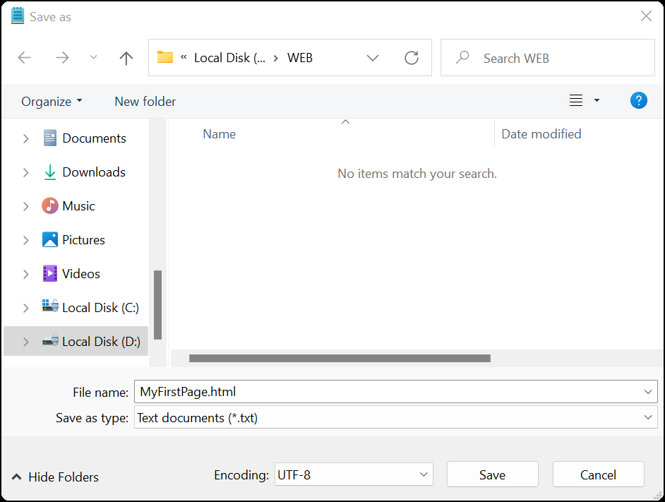
    - File name must have “MyFirstPage.html” or “.htm”
    - Click on the file MyFirstPage given below:
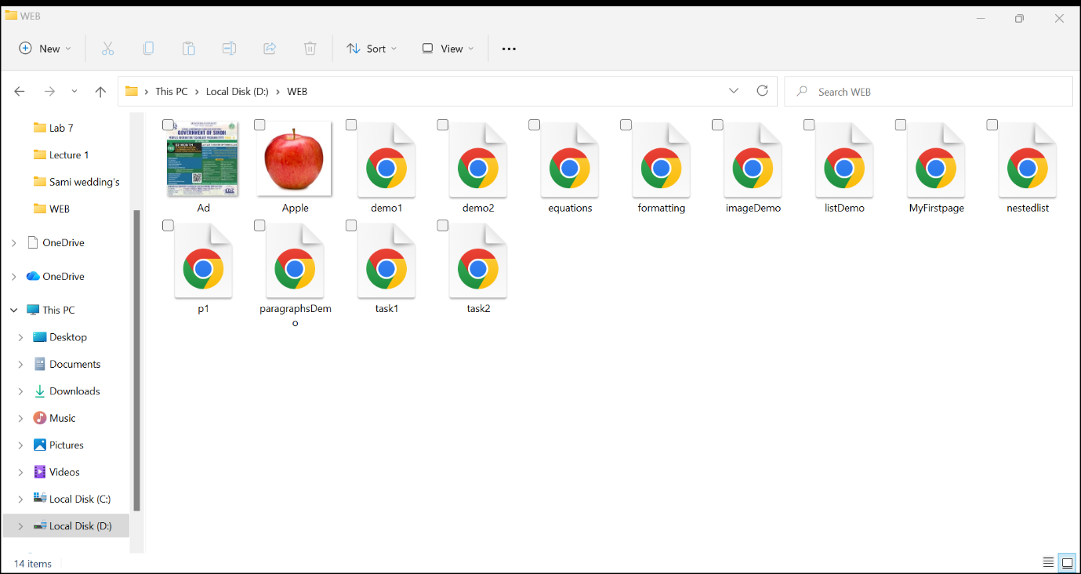
Post Lab Tasks
Task # 1 Practice the following tags:
<b> - Bold text
<strong> - Important text
<i> - Italic text
<em> - Emphasized text
<mark> - Marked text
<small> - Smaller text
<del> - Deleted text
<ins> - Inserted text
<sub> - Subscript text
<sup> - Superscript text

Task # 2 Insert Ordered List, Unordered List, Nested list using the following tags:
<h1> Aror Departments </h1>
<ol type="I">
<li> FEST</li>
<li> FOH </li>
<li> FOD </li>
</ol>

<h1> Aror Departments </h1>
<ul type="circle">
<li> FEST</li>
<li> FOH </li>
<li> FOD </li>
</ul>

<h1> Computer</h1>
<ol>
<!-- outer list -->
<li>Hardware</li>
<ul>
<!-- nested list starts here -->
<li> Input Devices </li>
<li> Output Devices</li>
<li> Storage Devices </li>
<li> Processing Devices</li>
</ul><!-- nested list ends here -->

<li>Software</li>
<ul>
<!-- nested list starts here -->
<li> System Software </li>
<li> Application Software </li>
</ul><!-- nested list ends here -->

</ol><!-- Outer list ends here -->

Task # 3 Design your CV in html.
Task # 4 Insert Images
<h1> A for Apple</h1>
<hr>
<img src="apple.jpg" title="Advertisement" alt="This is a picture" width="200" height="200">

- Write an educational page for the kids to teach them English Alphabets. Your Webpage should Contain the Alphabets and pictures.
- Use <hr> tag to insert the horizontal Rule.
Task # 5 Practice the following tags: [Post Lab Tasks]
<blockquote>,<q>, <abbr>, <address>, <cite>, and <bdo>
Example 1
<p>Here is a quote from WWF's website:</p>
<blockquote cite="http://www.worldwildlife.org/who/index.html">
For 60 years, WWF has worked to help people and nature thrive. As the world's leading conservation organization, WWF works in nearly 100 countries. At every level, we collaborate with people around the world to develop and deliver innovative solutions that protect communities, wildlife, and the places in which they live.
</blockquote>

Example 2
<p>WWF's goal is to: <q>Build a future where people live in harmony with nature.</q></p>

Example 3
<p>The <abbr title="World Health Organization">WHO</abbr> was founded in 1948.</p>

Example 4
<address>
Written by John Doe.<br>
Visit us at:<br>
Example.com<br>
Box 564, Disneyland<br>
USA
</address>

Example 5
<p><cite>The Scream</cite> by Edvard Munch. Painted in 1893.</p>

Example 6
<bdo dir="rtl">This text will be written from right to left</bdo>

Tags Summary
<abbr> Defines an abbreviation or acronym
<address> Defines contact information for the author/owner of a document
<bdo> Defines the text direction
<blockquote> Defines a section that is quoted from another source
<cite> Defines the title of a work
<q> Defines a short inline quotation

